**Creating Land Use Projects How-To**

This tool allows you, the planning staff, to create shapes (we’ll also call them polygons, features, or projects) that show where subdivisions, CUPs, rezones, and other major land use projects are under consideration. The tool also generates the aerial and vicinity maps as well as the mailing list for the project.

Once created, these polygons will appear in the internal Development Services webmap and the public Current Major Land Use Applications webmap.

**CREATING PROJECTS**

Internally, this tool works by copying the shape(s) of existing parcel(s), creating a new feature in the land use projects dataset with this shape, and adding the attributes you provide to this new feature.

Projects that do not perfectly align with parcel boundaries (mainly ME or PI overlay zones) pose a problem. You have two options:

1. Use this tool to generate the project based on the parcels affected and then have the GIS staff edit the shape to match the proper rezone boundary. This will generate maps and a mailing list based on the parcel boundaries, not the more specific boundary edited later.
2. Have the GIS staff manually create the project. We will also have to generate custom maps and a mailing list manually.

The following steps outline the process for creating these features for the vast majority of projects that will be heard by the Director, the Planning Commission, or the County Council:

1. Click on the Create Land Use Project widget: 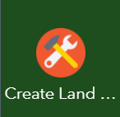
2. Type the parcel number of the affected parcels. If there are multiple parcels associated with a project, you can add additional fields with the blue plus button 
3. Enter the relevant information into each field.
   1. The Staff Report field is just a text field. It should contain the link to the publicly-posted staff report for the project. If the staff report is not yet complete, you can say something like “Forthcoming” or “In Process.”
4. When you are finished filling in the fields, hit the Execute button.
5. The widget will switch to the Output tab and start working. This can take a minute or two to complete (the main bottleneck right now is getting the imagery for the aerial map).
6. Once the tool finishes its work, three links will appear in the Output tab for the mailing list, vicinity map, and aerial map. Click on these links to download the comma-separated value (.csv) mailing list file and the two JPEG maps (your browser may open the JPEGs in the browser instead of downloading them; if that’s the case, right click the map and select Save As).

*Note: The maps and mailing list are created when the project is created; there is currently no way to automatically regenerate these documents. One possible work around would be to delete the project and run the tool again to recreate the project (and yes, I realize that’s a pain—the functionality of the script is limited by ESRI’s stock geoprocessing widget framework).*

**EDITING PROJECTS**

After a project has been created, you can go back and edit the fields to update the meeting times or add a staff report.

Edit the Active field to hide projects that have been completed and don’t need to be visible to the public. An active status of “Yes” will appear on your map as yellow and will appear on the public-facing map, while an active status of “No” will appear red on your map and **will not appear** on the public map.

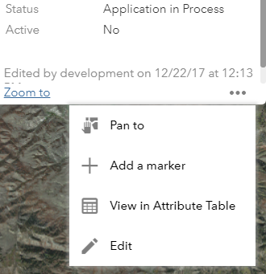

1. There are two ways to open the Edit widget and enter edit mode:
   1. Click on the project to open its popup. Click the ellipses at the bottom right of the popup and select “Edit:”
   2. Click the Edit Land Use Projects widget:
2. While the edit widget is open, anytime you click on a parcel it will bring up the edit popup instead of the normal popup. To bring up the normal popups instead, close the Edit widget with the “X” in the top corner or by opening another widget.
3. You can change any of the fields in the edit popup (though sometimes a field may be grayed-out and not editable due to the services behind the scenes being persnickety; let us know if that’s the case).
   1. You can’t change the shape itself, so don’t worry about panning around the map while in edit mode.
4. Your changes will take effect immediately; there’s no Save button to click. Once you’re done with your edits, hit “Close” at the bottom or close the popup with the “X” in the corner.
5. If you want to delete the project, select “Delete” at the bottom of the popup. This is permanent; there is no undo for deleting projects.

**ERRORS**

Naturally, this tool will run perfectly, every time, from now to eternity. If cosmic rays strike gain and it somehow fails, it will give a failure message in the Output tab. There are a couple things to do if it errors out:

1. Check your parcel numbers. The tool will fail if the number is not in the format ##-###-####, or if the parcel does not exist.
2. Try closing your browser, relaunching, and creating the project again. If the shape shows up on the map when you relaunch, you can either delete it and start over or ask us to create custom maps and the mailing list.
3. If all else fails, give us a call. We can turn debug mode on and see what errors the script is returning.